10000/10000 [==============================] - 4s 361us/sample - loss: 0.0163 - acc: 0.9184
The testing accuracy metric for 0.01 learning rate is [0.016293086968041878, 0.9184]
---------------------------------------------------
10000/10000 [==============================] - 4s 362us/sample - loss: 0.0051 - acc: 0.9745
The testing accuracy metric for 0.1 learning rate is [0.005085394600779413, 0.9745]

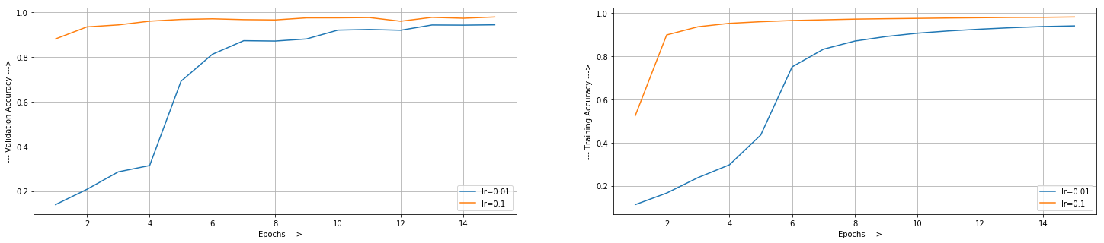
Learning Rate vs Accuracy:
- N=0.01: When the learning rate was this small, it is taking time to gain some accuracy. That’s why we see that training and validation accuracy is bit low in this case as compared to N=0.1. It took around 8 epochs to get to significant accuracy. While it took only 2 epochs for learning rate 0.1.
- N= 0.1: the model learned very quickly. We can also see that , the validation accuracy reached around 80% after two epoch only for lr=0.1, while the one with learning rate 0.01 is at 22%. But sometimes increasing learning rate beyond limit also creates problem. It shoots out of the optimal solution and accuracy starts decreasing.

